CaseManagement_CreationOfCase_Instance23_06-Aug-2018_03-24-14_AM_EnterTextAction.png

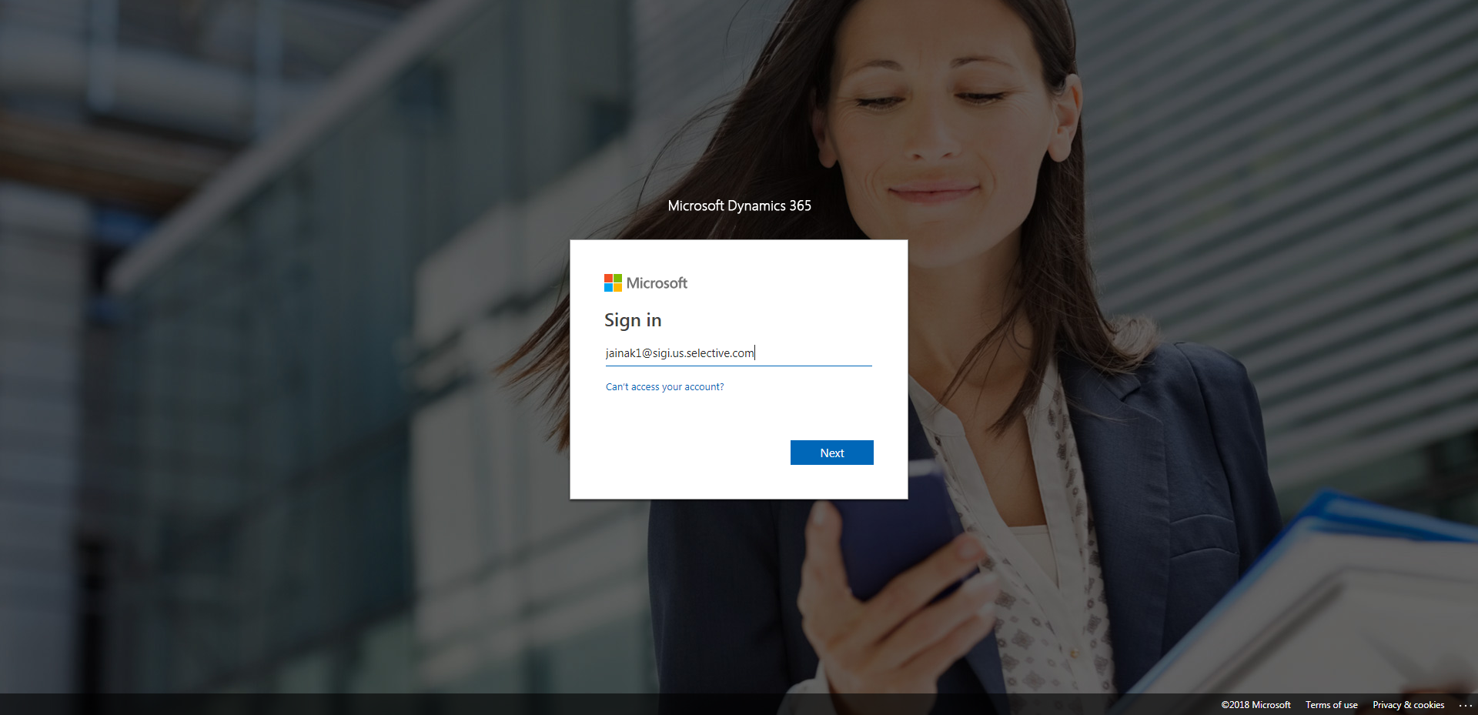

CaseManagement_CreationOfCase_Instance23_06-Aug-2018_03-24-16_AM_MouseClickActiononStaleElement.png

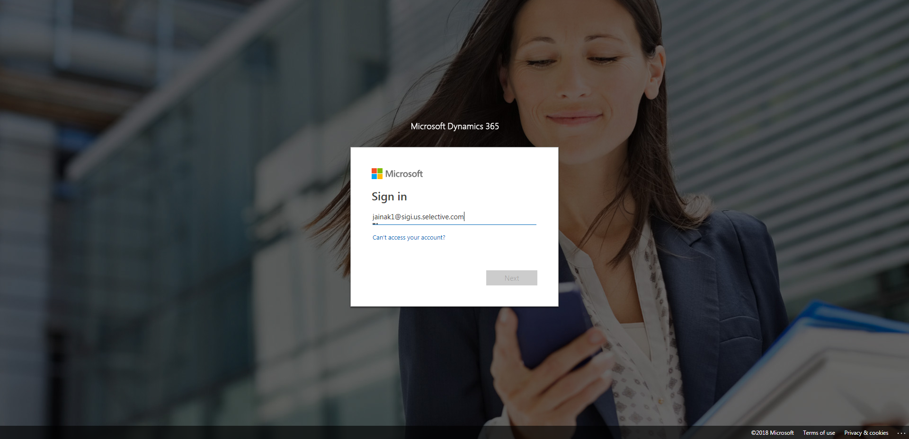

CaseManagement_CreationOfCase_Instance23_06-Aug-2018_03-24-37_AM_SingleSignOn.png

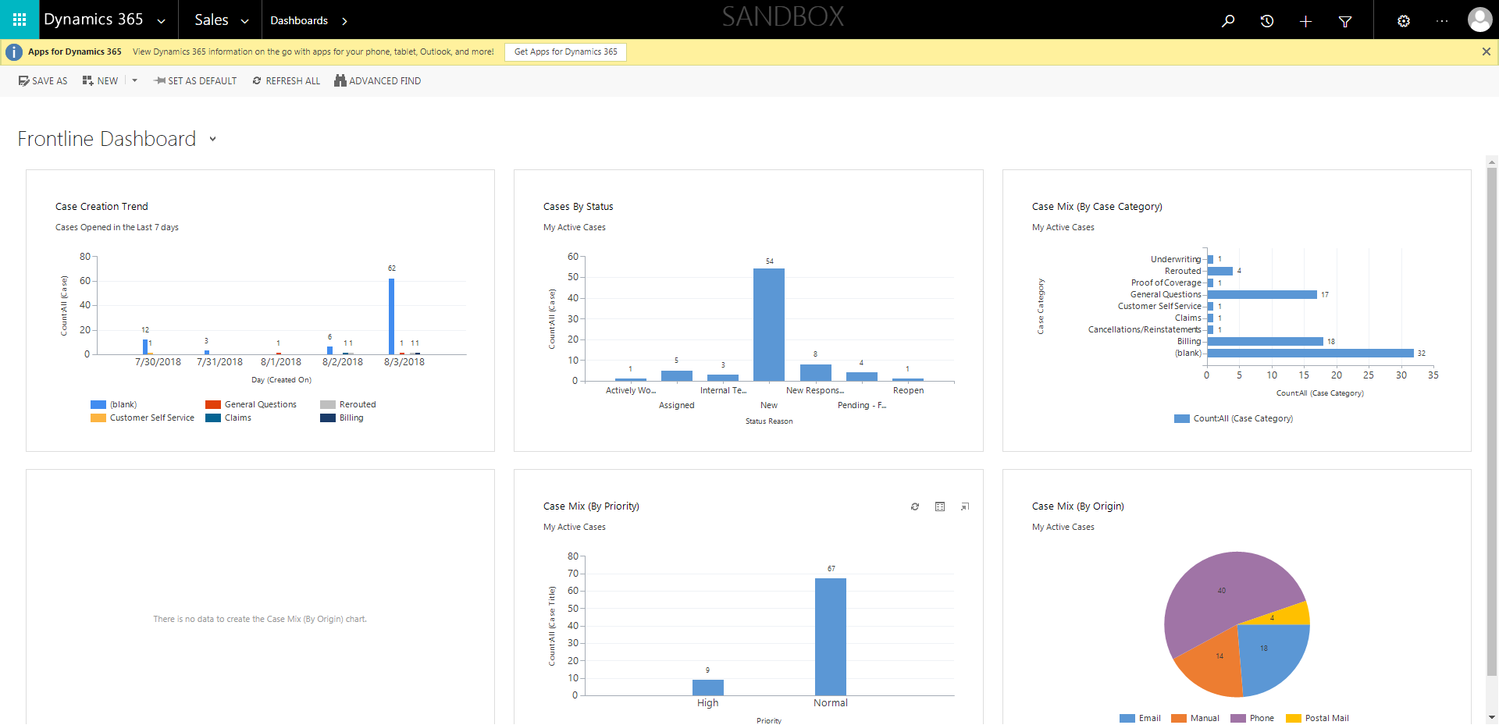

CaseManagement_CreationOfCase_Instance23_06-Aug-2018_03-24-35_AM_SingleSignOn.png

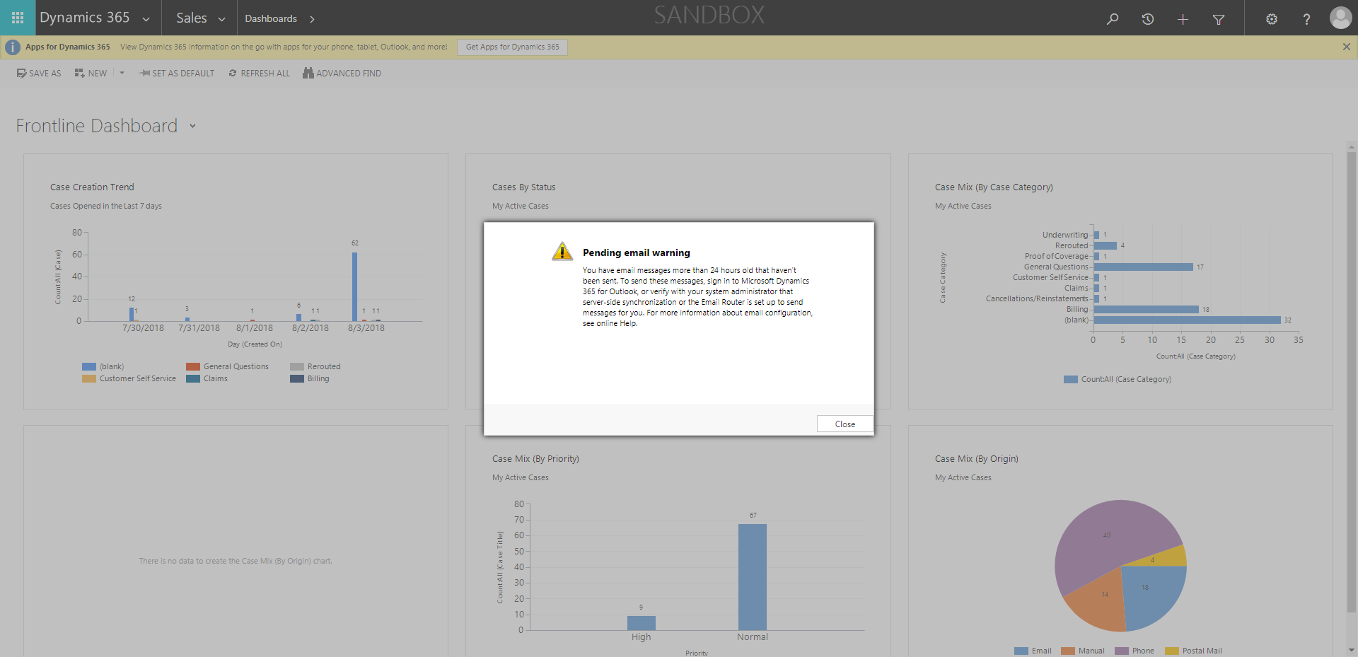

CaseManagement_CreationOfCase_Instance23_06-Aug-2018_03-24-58_AM_MouseClickActionMoveToElementByxpathimgaltServiceparentspan.png

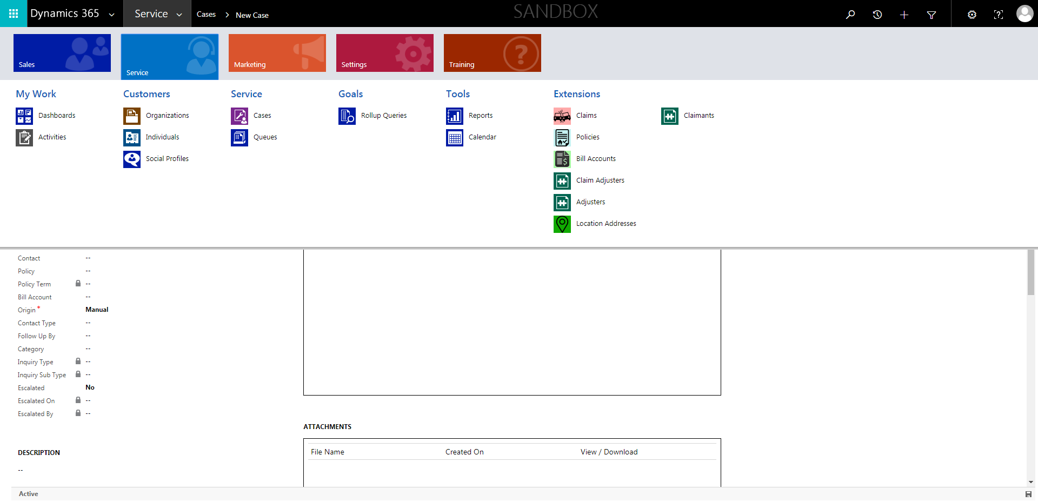

CaseManagement_CreationOfCase_Instance23_06-Aug-2018_03-24-41_AM_MouseClickActionMoveToElementBycssSelectorspanTabSFA.png

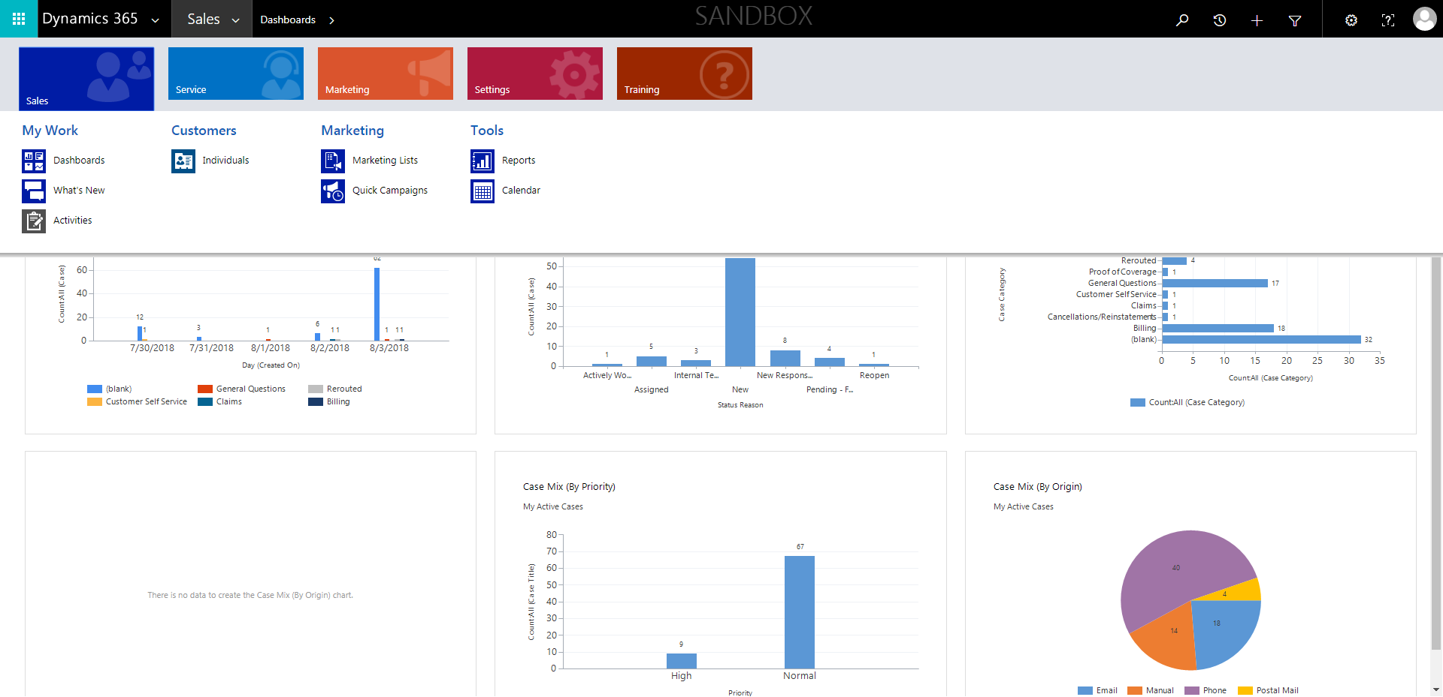

CaseManagement_CreationOfCase_Instance23_06-Aug-2018_03-24-44_AM_MouseClickActionMoveToElementBycssSelectoranavcases.png

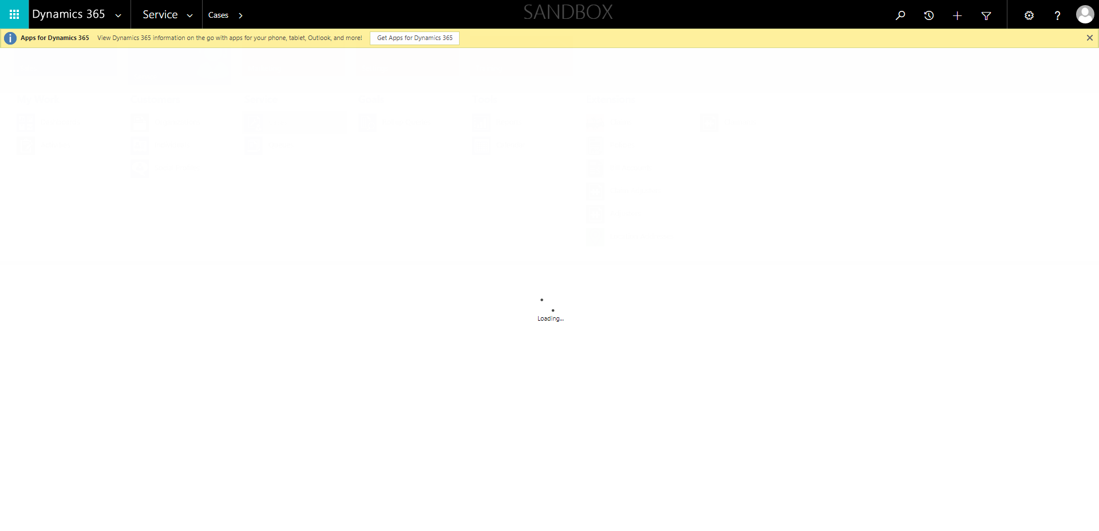

CaseManagement_CreationOfCase_Instance23_06-Aug-2018_03-24-13_AM_MouseClickActiononStaleElement.png

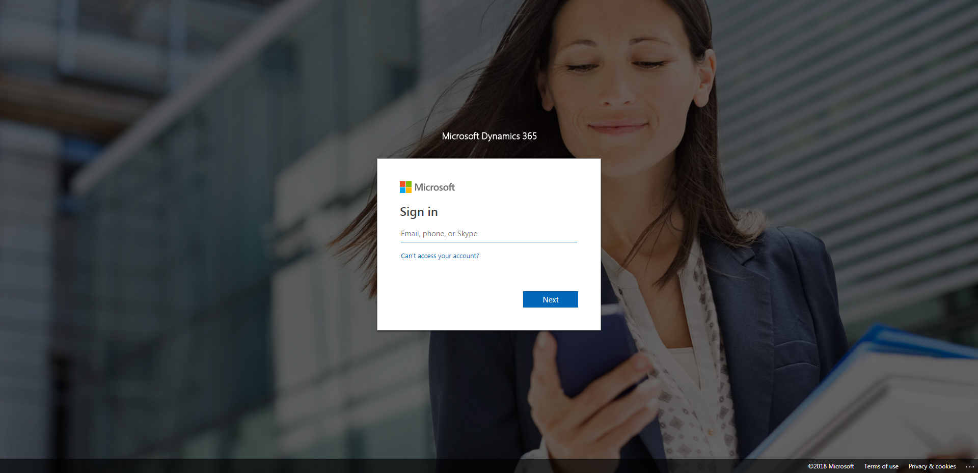

CaseManagement_CreationOfCase_Instance23_06-Aug-2018_03-24-43_AM_MouseClickActionMoveToElementByxpathimgaltServiceparentspan.png

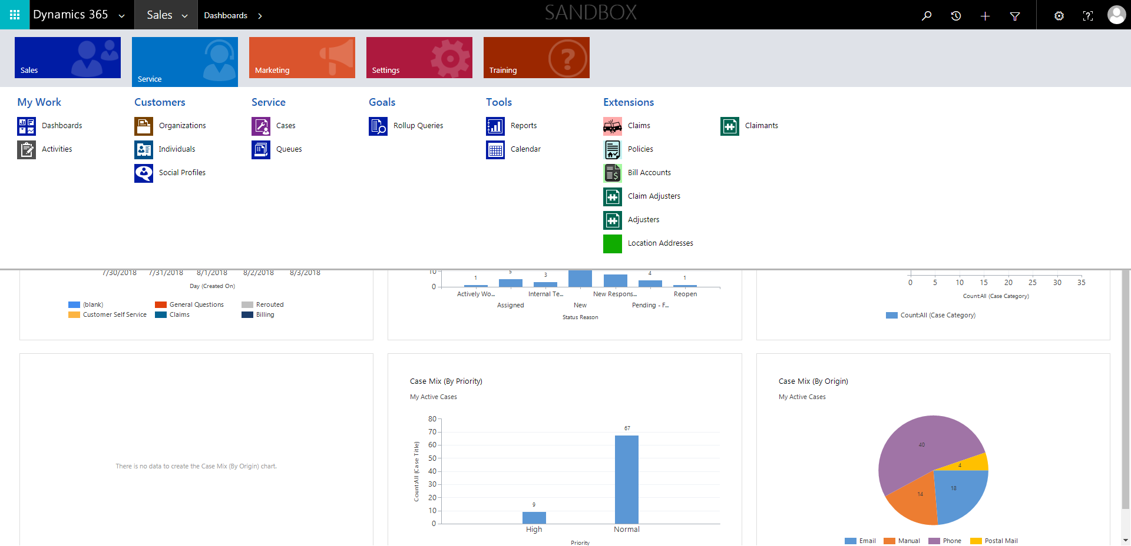

CaseManagement_CreationOfCase_Instance23_06-Aug-2018_03-24-58_AM_MouseClickActionMoveToElementBycssSelectorspanTabCS.png

